My project is a choice oriented storyline game, different choices will lead to different branch plots and ultimately lead to different endings. The entire project will be implemented in HTML, CSS, and JavaScript. The text data will be saved in XML file format, and the images used in the project will be generated by Midjourney. This is a web game that players only need to click to operate, and it will be background music, allowing players to choose to pause. This is a single person project, and I will be responsible for all work, including development and testing.

This project is written by Javascript, css, xml, and html.

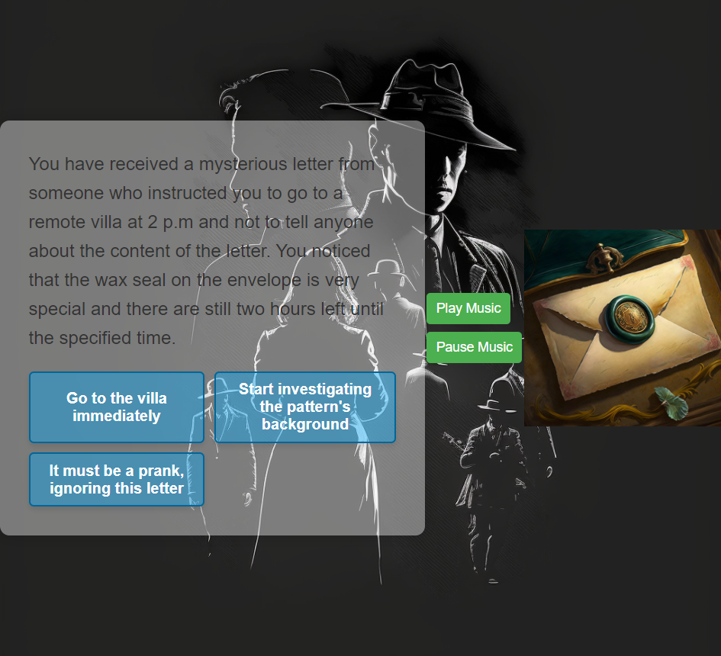

Here is an example for the user interface. The pictures shown do not represent the final result.

I also set up a start screen, user can start game by clicking a Start button. The start screen has a different UI. User can start or pause music by clicking these two buttons. The default mode for background music is autoplay and loop. For each question, user can make their own decision in at most 4 options. There is a picture display area on the right side of the interface. As the story progresses, the pictures will change accordingly. All images in this project are generated by AI Midjourney based on keywords. I set the key tone so that when the user clicks on the option, it will sound and when the user's mouse is over the option, the option will enlarge and change to a more obvious color.

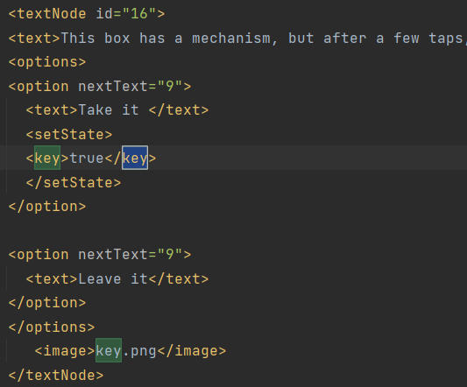

Here is an example of data which stored in XML form are used in this project.

<textNode> specifies the id of each question and <text> is the description. <options> includes all of options that user can choose from. <option> specifies the next question for each option. <setState> is the partner of <requiredState> because some options must have a specific state to trigger. <image> is the corresponding picture.

Whether the user succeeds or fails, the game can be restarted by clicking the Restart button. Depending on what the user chooses, about 70 conversations can be played.